MongoDB Assignment – Employee Queries

Question 1: Retrieve all employee records.
Query:
db.employees.find()
Answer 1:
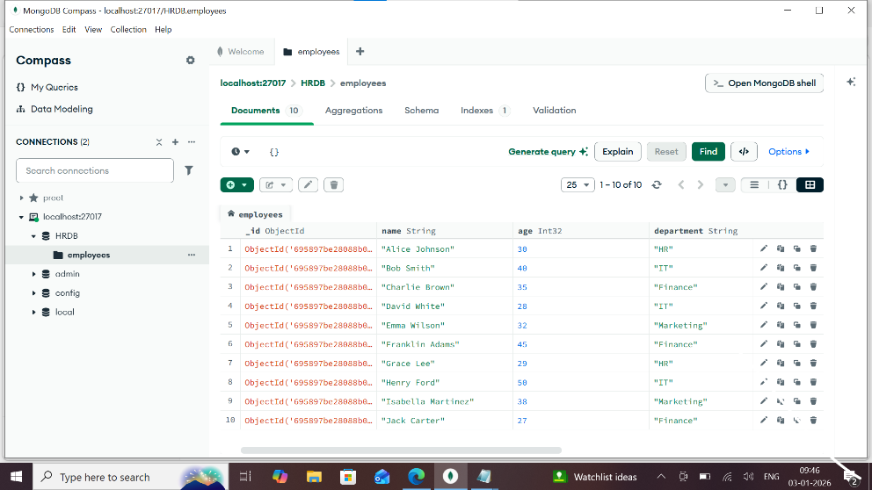

Question 2: Find employees who work in the IT department.
Query:
db.employees.find({ department: 'IT' })
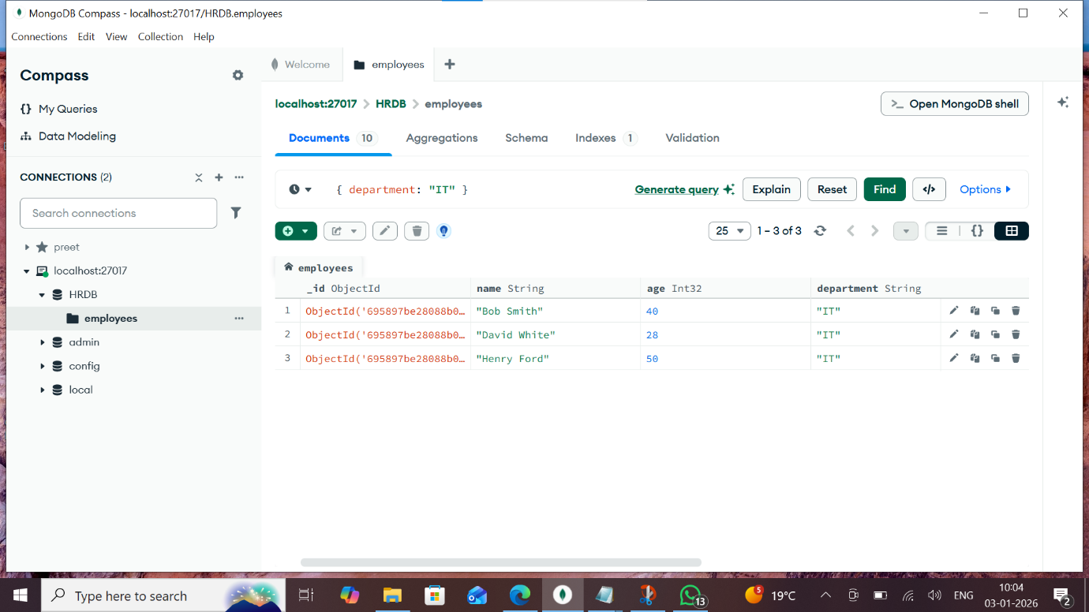

Question 3: Find employees who have a salary greater than 70,000.
Query:
db.employees.find({ salary: { $gt: 70000 } })
Answer 3:
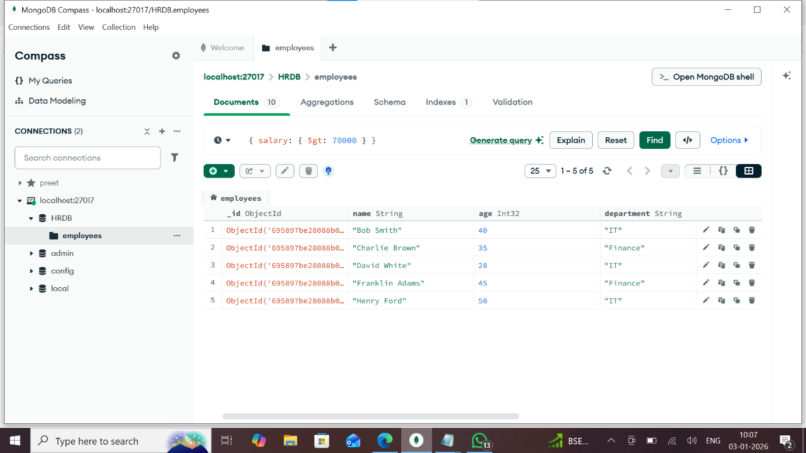

Question 4: Find employees who joined after 2018.
Query:
db.employees.find({ joiningYear: { $gt: 2018 } })
Answer 4:
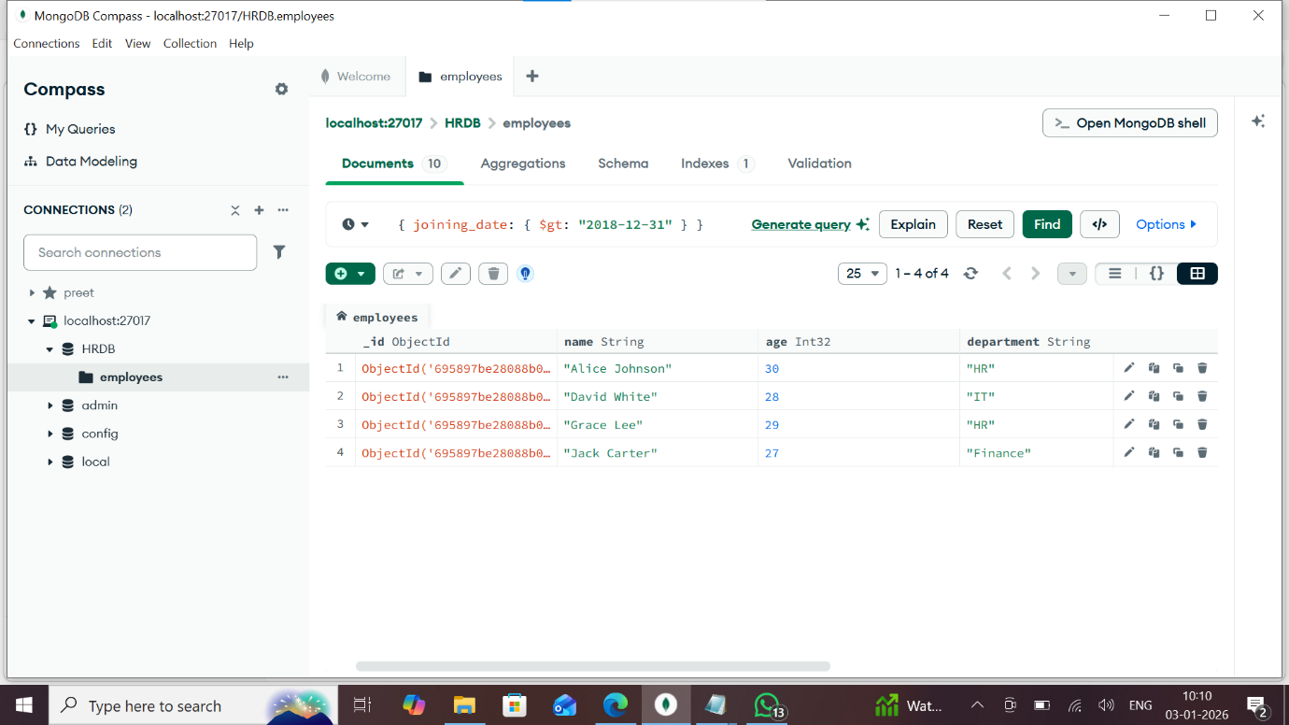

Question 5: Find employees between the ages of 30 and 40.
Query:
db.employees.find({ age: { $gte: 30, $lte: 40 } })
Answer 5:


Question 6: Increase the salary of all employees in the Finance department by 5%.
Query:
db.employees.updateMany(
{ department: 'Finance' },
{ $mul: { salary: 1.05 } }
)
Answer 6:
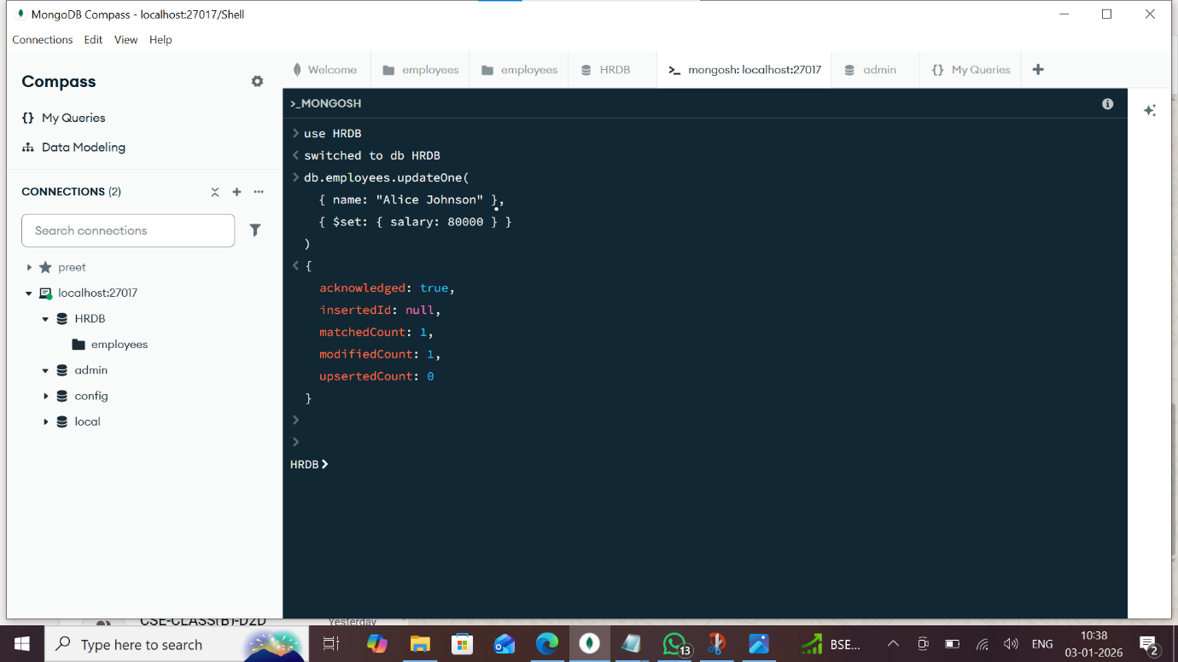

Question 7: Delete employees who joined before 2010.
Query:
db.employees.deleteMany({ joiningYear: { $lt: 2010 } })
Answer 7:


Question 8: Find the highest-paid employee.
Query (Aggregation - Works in all editors):
db.employees.aggregate([
{ $sort: { salary: -1 } },
{ $limit: 1 },
{ $project: { _id: 0, name: 1, salary: 1 } }
])
Answer 8:
